TCR-102


ELECTRIC RICE COOKER

Instruction manual

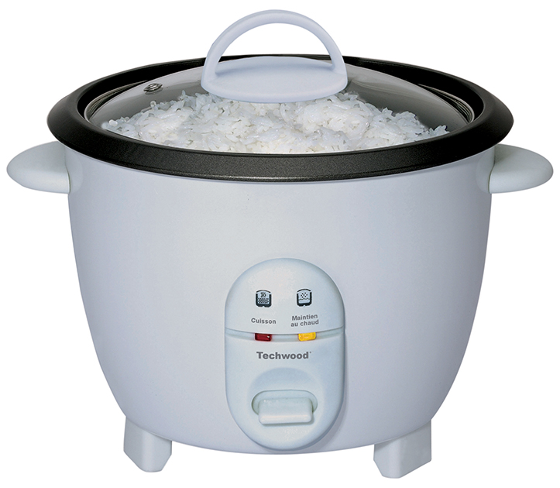
IMPORTANT SAFEGUARDS
Dear consumer, Please read these instructions carefully before use in order to avoid damage due to incorrect use and to better understand the functions of this product. Please pay particular attention to the safety guide.
If you pass the device on to a third party, these Operating Instructions must also be handed over.
Please keep them for future references.

- Please read these instructions carefully before use.
- Keep present instructions for future references.
- Check that your mains voltage corresponds to that stated on the appliance.
- Only use the appliance for domestic purposes and household or similar applications such as:
- staff kitchen areas, in shops, offices and other working environments;
- By clients in hotels, motels and other residential type environments;
- Environment type like :
• Farm Houses • Bed and Breakfast.
- Only use the appliance in the way indicated in these instructions.
- Never use this unit near bathtub, shower, wash-hand basins or other containers with water.
- Never use this apparatus near water projections.
- Never use this apparatus with the wet hands.
- If, unfortunately the apparatus is wet, immediately withdraw the cord of the socket-outlet.
- Inform potential users of these instructions.
- Never leave the appliance unsupervised when in use.
- The appliance must be used only for its intended purpose. No responsibility can be taken for any possible damage caused by incorrect use or improper handling.
- Children and persons with disabilities are not always aware of the danger posed by the use of appliances.
- This appliance can be used by children aged from 8 years and above if they have been given supervision or instruction concerning use of the appliance in a safe way and if they understand the hazards involved.
- Cleaning and user maintenance shall not be made by children unless they are older than 8 and supervised.
- Keep the appliance and its cord out of reach of children aged less than 8 years.
- Appliances can be used by persons with reduced physical, sensory or mental capabilities or lack of experience and knowledge if they have been given supervision or instruction concerning use of the appliance in a safe way and understand the hazards involved.
- Children shall not play with the appliance.
- In order to ensure your children‘s safety, please keep all packaging (plastic bags, boxes, polystyrene etc.) out of their reach.
- Caution ! Do not allow small children to play with the foil :
there is a danger of suffocation !
- From time to time check the cord for damages. Never use the appliance if cord or appliance shows any signs of damage.
- Never immerse the appliance in water or any other liquid for any reason whatsoever.
- Never place it into the dishwasher.
- Never use the appliance near hot surfaces.
- Do not operate the appliance with a damaged cord or plug, or after the appliance has been damaged in any manner. If the supply cord or appliance is damaged, it must be replaced by the manufacturer or its service agent or a similarly qualified person in order to avoid a hazard.
- Disconnect the power source cable before any operation of cleaning of maintenance and accessories assembly.
- Never use the appliance outside and always place it in a dry environment.
- Never use accessories, which are not recommended by the producer. They could constitute a danger to the user and risk to damage the appliance.
- Never use any other connector than the one provided.
- Never move the appliance by pulling the cord. Make sure the cord cannot get caught in any way.
- Never wind the cord around the appliance and do not bend it
- Ensure that the power cord does not come into contact with hot parts of this unit.
- Make sure the appliance has cooled down before cleaning and storing it.
- The temperature of accessible surfaces may be very high when the appliance is operating. Never touch these parts, of apparatus, to avoid burning itself.
- Make sure the appliance never comes into contact with flammable materials, such as curtains, cloth, etc...& the power cord and plug do not come in contact with water.
- Before cleaning, always unplug the appliance from the power supply and let it cool down.
- This appliance is not intended to be operated by means of an external timer or separate remote-control system.
- Always place the unit on a flat surface. Ensure, also, not to cover the device and not to put anything on it.
- Always remove the plug from the wall socket when the appliance is not in use.
- When using an extension lead always make sure that the entire cable is unwound from the reel. Use solely CE approved extension leads. Input power must be at least 16A, 250V, 3000W.
- Incorrect operation and improper use can damage the appliance and cause injury to the user.
- This device, designed for home use, complies with standards relating to this type of product.
- The appliance must be used and rested on a table or flat & stable surface.
- The item must not be left unattended when it is connected to main supply.
- The item is not to be used, if it has been dropped or if there are visible signs of damage or if it is leaking.
- Regarding the instructions for cleaning, thanks to refer to the below paragraph of the manual.
- This appliance is only intended for household use.
- Warning: Avoid spilling on the connector.
There is a potential risk of injury if used incorrectly.
The surface of the heating element may remain hot for some time after use.

^{(*)} Competent qualified person : after sales department of the producer or importer or any person who is qualified, approved and competent to perform this

GENERAL INFORMATION

The symbol "OPEN BOOK" means a recommendation to read important things contained in the record.

The symbol "BIN" crossed out, abbreviation WEEE (Waste of Electrical and Electronic Equipment) means that at the end of life, it should not be discarded with household waste, but filed to the sorting of the locality. Waste recovery can help preserve our environment.
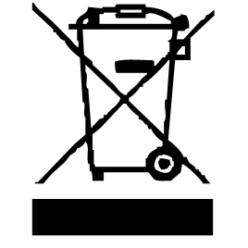

The symbol "STEAM" warns the user that steam can escape from the unit and to take all necessary precautions. (Risk of burns)

The symbol "CE" is the guarantee of compliance with harmonized European standards, voluntary, reflecting the essential requirements into technical specifications. These standards are not mandatory but are guarantees of compliance with essential requirements.


The symbol "GLASS / FORK" means that the device is compatible and can come into contact with foodstuffs.

The symbol ROHS (Restriction of use of some Hazardous Substances) on the Environmental Protection, certifies that for each of the five hazardous substances • Lead • Mercury • (hexavalent) chromium • products for protection against flames PBB and PBDE, the peak concentration is equal to or less than 0.1% of the weight of homogeneous material, and 0.01% for the 6th • cadmium.


The symbol "TRIMAN" indicates that the consumer is invited to dispose the product as part of a separate collection (eg recycling bin, waste, voluntary intake point).


For more information : http://www.quefairedemesdechets.fr

FIRST USE

Before first use, remove the unit and all accessories carefully and paying attention to the sharp accessories.

Clean with soap and water, bowls and all accessories. Rinse and dry thoroughly. Clean the outside and inside of the machine cabinet with a damp cloth and wipe dry.

INTRODUCTION

The rice cooker provides a simple method of perfect rice cooking.
The warm function automatically keeps the rice warm, fluffy and ready to serve for up to 5 hours.
Many other foods can be cooked in the rice cooker such as vegetables, fish, meat, seafood and poultry.

LOCATION
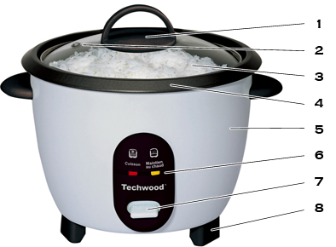

1. Handle
2. Security Hole
3. Glass lid
4. Inner container
5. Bain Body or Base
6. Pilots lights
7. Selector : cooking / flat heater
8. Feet
At the back of the unit : On / Off switch (see use)

USE

- Unroll the power cord completely.
- Check that the tension in force in the country where you are, corresponds to that indicated on the apparatus.
- Connect the apparatus in a correct socket-outlet, (and connected to the ground if the unit is Class I), to avoid any danger.
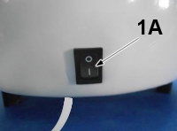
- Set the ON / OFF button (2) on “ON” position.
- The pilot light will light up.

- Disconnect the power source cable before any operation of cleaning of maintenance and accessories assembly.

Stand the appliance on a table or flat surface.
- Never modify the appliance in anyway.
- Place the inner container in the cooker before use.
Note: The cooker will work only if the inner container is in place.
- Set the cooking selector to "Cooking".
- When the rice or other food is cooked, the cooker will automatically move to the "Keep Warm".
Note: ALWAYS TURN THE SWITCH ON / OFF ON OFF AFTER USE Otherwise, the cooker will remain powered. (If it is not unplugged).
- Place the lid on the device during cooking.
- Leave the lid in place after serving to prevent the rice from drying out.
- To reheat cold rice, add cold water, a quarter of the measure by measure of rice, stir, then place the button on "Cooking".
Note: To prevent malfunctioning, leave no material contact with the hot plate or the bottom of the inner container.

Preparation

  - Before each use, ensure that the outside of the rice bowl is clean and dry and that the heat sensor in the center of the heating plate, on the inside of the base, is clean, dry and cool.
  - Handle the rice bowl carefully. Scratching or denting the bowl may result in unsatisfactory performance. The heat sensor needs to establish contact with the rice bowl, if not the rice will not cook properly.

How to Cook Rice

  - Using the measuring cup provided measure out the required quantity of rice and water. (Consult Rice Cooking Chart)
  - Add the rice and water to the rice bowl ensuring that both the rice and water are evenly spread across the bowl.
  - Place the rice bowl into the base and place the lid into position on the rice bowl. Ensure that the rice bowl makes proper connect with the heat sensor on the heating plate.
  - The rice will keep warm for up to 5 hours. Please ensure that you have at least 3 cups of cooked rice in the rice bowl for the WARM indicator function.
  - If you do not require the WARM function simply unplug the power cord from the power outlet.

RICE COOKING CHART

Raw Rice Water

2 cups 3 - 3½ cups
4 cups 5 - 5½ cups
6 cups 7 - 7½ cups
8 cups 9 - 9½ cups
10 cups 11 - 11½ cups
These measurements are given for information only. They may be different depending on personal experiences.

Note: For a softer rice, mix the rice and water in the inner container
and let soak for 10 minutes before cooking.
• Put the lid on the cooker.
• Connect the cooker.
• Set the selector to "Cuisson = Cook".
Note: When your rice is ready, the cooker will automatically set the selector to "Maintien au chaud = Keep warm".
• After cooking, let the rice rest for at least 5 minutes without removing the lid. This will ensure perfect cooking.
• The brown rice is longer to cook and we recommend adding 2/3 of a measure of water to be adapted to the cooking time.

CLEANING AND MAINTENANCE

Before cleaning, Always : switch off the appliance, disconnect the apparatus and let it cool.
Clean the outside of the apparatus with a sponge or slightly wet linen.
The parts (removable) in contact with food like plate, bowl, forks, Spatula etc. can be washed in hot water with sponge and soft detergent or put in the dishwasher.
Never plunge the apparatus in water or all other liquid !
Do not use abrasive cleaners, gritting, or metal brush or another cutting object.
If cooked rice sticks to the bottom of the rice bowl fill the rice bowl with warm soapy water and let stand for approximately 10 minutes.

STORAGE

-Ensure the unit is completely cool and dry.
-Do not wrap the cord around the appliance, as this will cause damage.
-Keep the appliance in a cool, dry place and out of reach from children.

GUARANTEE

Before being delivered, all our products are subjected to a rigorous control.

This apparatus is guaranteed 24 months starting from the date of purchase by the consumer.

The documents in proof of guarantee are :

• The invoice and

• The filled and stamped warrantee plate (located on side or bottom of the gift box). Without these documents in proof, no free replacement, nor no free repair, can be carried out.

During the warranty period, we deal for free, the defects of the apparatus or the accessories, rising from a defect of materials or manufacture by repair or, replacement. The services within the framework of the guarantee do not involve any extension of the warranty period and does not give right to a new guarantee !

In the event of recourse to the guarantee, bring back the complete apparatus to your retailer, in its original packing, accompanied by the proofs of purchase.

The breakage of parts out of glass or plastic is, in all the cases, not warranted. Defects on the accessories or the wearing parts (for example: coals of engines, hooks, drive belts, remote control of replacement, teeth brushes of replacement, webs etc) as well as cleaning, maintenance or it replacement of wearing parts are not guaranteed and are thus to pay !

In the event of foreign intervention, the guarantee becomes null and void.

After flow of the warranty period, repairs can be carried out, against payment, by a specialized trade or a repair service.

SPECIFICATIONS

Power supply 220-240V~ 50-60Hz
Power 400W
Norm Class I

The characteristics can change without prior notice.

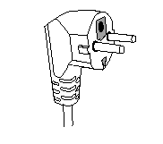
This unit is equipped with an electrical outlet with earth and must be earthed in an according plug.
Note : In the event of question concerning the earth or electric connection, please consult a qualified personnel.
In the event of short-circuit, earthing reduces the risk of electric shock while making possible the current to be evacuated by the wire of ground.

CAUTION: In order to minimize the risks of electric shock, In the event of breakdown, not to open the case but to call upon a qualified technician for repairs.

This device complies with EC directives, it was controlled according to all current European directives, applicable such as: electromagnetic compatibility (EMC) and low voltage (LVD).

This device has been designed and manufactured in compliance with the latest regulations and technical requirements for safety.

Imported by Sotech International
" LE PERIPOLE " N°A-107
33, Avenue du Marechal de Lattre de Tassigny
94120 Fontenay sous-bois - France

